**Group 8 – Report Summary**

By looking at the game title release and total sales numbers in the past 20 years, we would like to see if there is any causal relationship between the big title games (software) and the corresponding game console (hardware) sales.

We obtained two sets of data: Game sales since 1971 ([Maven Analytics Data Playground](https://www.mavenanalytics.io/data-playground)) of 64,016 titles across 39 consoles, and game console sales in the last 20 years([vgchartz.com](https://www.vgchartz.com/tools/hw_date.php)) for 13 consoles. We’ve done some clean up and joined the two sets of data in order to look at the data from a few different perspectives.

Initially, we located the best-selling games for each console. With each game-console pair, we showed the hardware sales numbers before and after the game release date. It’s a mixed results that there’s no definite indication where the game sale caused a big push of hardware sale. When we look at the total number of game titles released, we can tell there was positive correlation between the game titles and the hardware sale numbers.

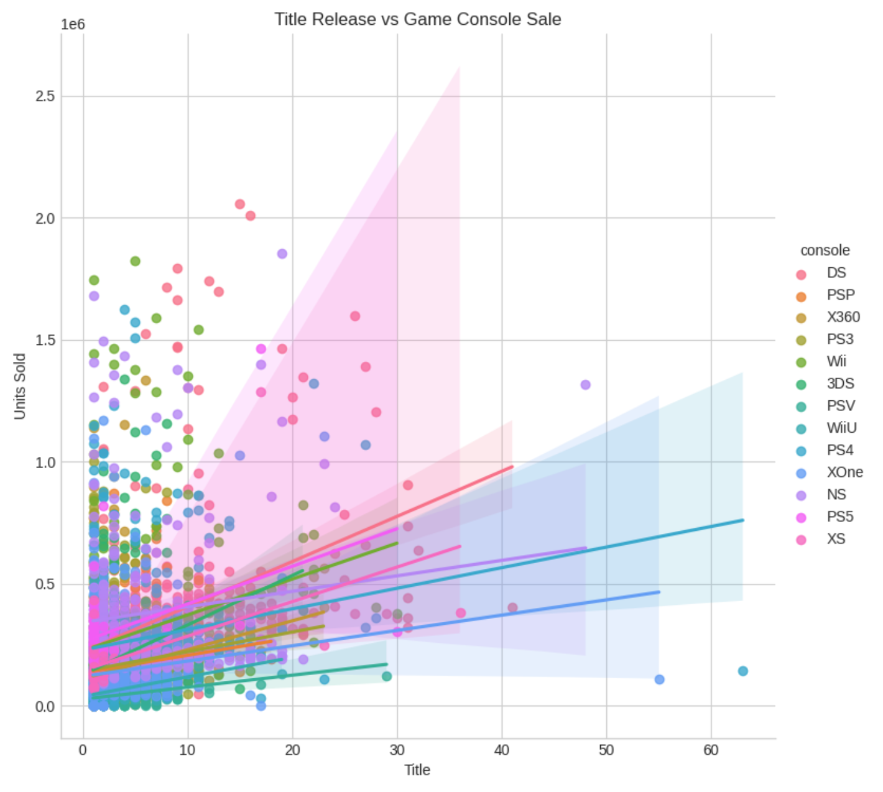

We’ve further looked at the console sales with the aim being to see if there was any particular trend or pattern by using autocorrelation plots. By looking at the plots, we could see there was indeed a cyclical pattern. More precisely, it was a seasonal pattern we’ve observed for the sales of game consoles.

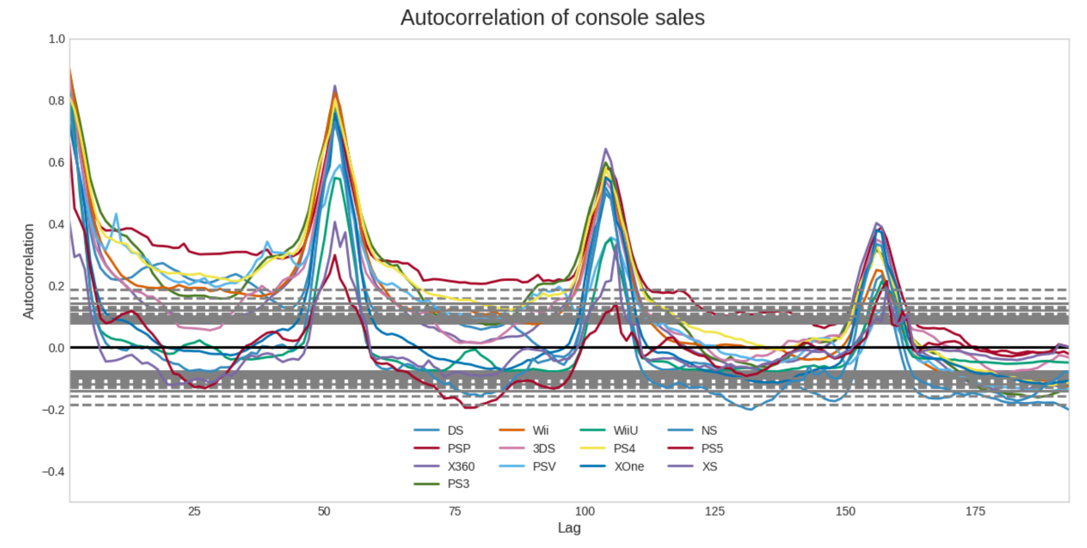

To verify the accuracy of our model, we had applied the Random Forest Regression to our data. We could tell there was positive correlation between the games release and console sales, but it was not very high. i.e., The popular games sales are important to the game console, but it was not the main reason or contribution to the sale of hardware.

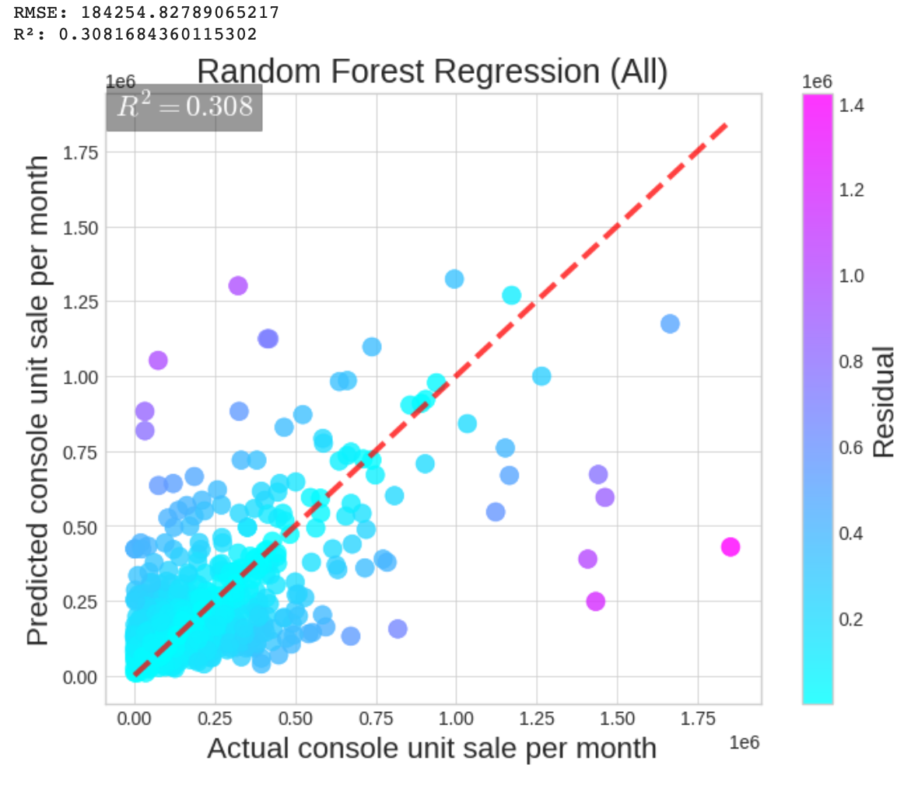

**Conclusion**

In conclusion, while intuitively there is reason to believe that big game releases drive console sales, we could not definitively prove this hypothesis through our analysis. However, we did find a positive, albeit weak, correlation between the sheer number of games released for a console and the console’s sales. We also found strong seasonal patterns in the console sales.